Course Code：101180111

Beijing Institute of Technology
University Physics (I) Final Examination A
10:10 A.M.-12:10 P.M. June 19th, 2022

Class（Major） Student ID Name

Problem | 1 | 2 | 3 | 4 | 5 | 6 | 7 | 8 | 9 | 10 | 11
Marks | 8 | 8 | 10 | 10 | 8 | 10 | 10 | 10 | 10 | 8 | 8

[Read the Following Instructions Carefully!]

Instructions: The exam contains 11 problems. Do not forget to write your full name, student number, and class number on each of every answer sheets. Copy problem numbers and solve problems step by step on your answer sheets so that your reasonings are clearly presented. Do not panic or be discouraged if you cannot do every problem; there are both easy and hard parts in this exam. If a part of a problem depends on a previous answer you have not obtained, assume it and proceed. Keep moving and finish as much as you can.

1. [8 Marks] For a motion with constant acceleration, the equation of average velocity is 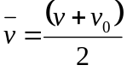. It is not valid for the case when the acceleration 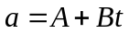, where A and B are constants. Prove that for this case 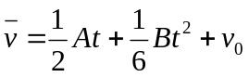, rather than 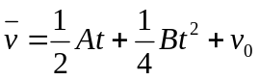.

2. [8 Marks] At time t=0, a 2150 kg rocket in outer space fires an engine that exerts an increasing force on it in the +x direction. This force obeys the equation F_{x}=At², where t is time, and has a magnitude of 781.25 N when t=1.25 s. (a) Find the value of the constant A, including its unit. (b) What impulse does the engine exert on the rocket during the 1.50 s interval starting 2.00 s after the engine is fired? (c) By how much does the rocket’s velocity change during this interval?

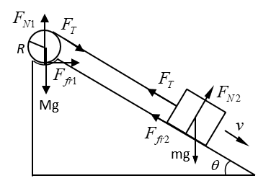
3. [10 Marks] A cord connected at one end to a block of mass m=3.0 kg which can slide on an inclined plane has its other end wrapped around a cylinder (radius R and mass M=30 kg) resting in a depression at the top of the plane as shown. The inclined plane makes an angle 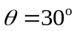with horizontal. Determine (a) the tension force F_{T}, friction forces F_{fr1} and F_{fr2}. (b) the speed of the block after it has traveled a distance D=1.80 m along the plane starting from rest. Assume the coefficient of friction between all surfaces is μ=0.035.

4. [10 Marks] A uniform rod of length L and mass 2m rests on a smooth horizontal table. A point mass m moving horizontally at right angle to the rod with an initial velocity 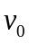 collides with one end of the rod and sticks to it. Determine (a) the rotational inertia about the axis passing through the center of mass after the collision, (b) the angular velocity ω of the system after the collision,(c) the position of the point on the rod which remains stationary immediately after the collision, and (d) the change in kinetic energy of the system as a whole as a result of the collision.

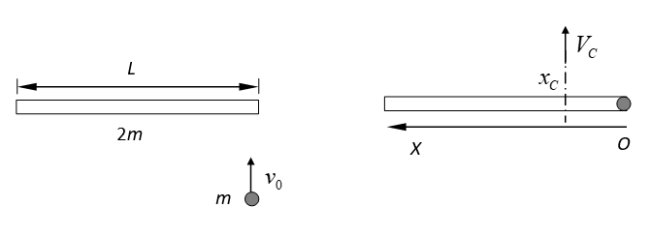

5. [8 Marks] (a) For what mass of molecule or particle is 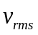equal to 1.00 mm/s at 300 K? (b) If the particle is an ice crystal, how many molecules does it contain? The molar mass of water is 18.0 g/mol. (c) Calculate the diameter of the particle if it is a spherical piece of ice. Would it be visible to the human naked eye?

6. [10 Marks] A cylinder contains oxygen at a pressure of 2.00 atm. The volume is 4.00 L and the temperature is 300 K. Assume that the oxygen may be treated as an ideal gas. The oxygen is carried through the following processes: (i) Heated at constant pressure from the initial state (State 1) to State 2, which has T=450K. (ii) Cooled at constant volume to 250K (State 3). (iii) Compressed at constant temperature to a volume of 4.00 L (State 4). (iv) Heated at constant volume to 300 K, which takes the system back to State 1. (a) Show these four processes in a PV-diagram, giving the numerical values of P and V in each of the four states. (b) Calculate the value of constant volume specific heat 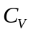 and constant pressure specific heat 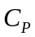 of oxygen by using the equipartition theorem of energy. (c) Calculate Q and W for each of the four processes. (d) Calculate the net work done by the oxygen. (e) What is the efficiency of this device as a heat engine? How does this compare to the efficiency of a Carnot engine operating between the same minimum temperature 250 K and maximum temperature 450 K?

7. [10 Marks] A certain brand of freezer is advertised to use 730 kW·h of energy per year. (a) Assuming the freezer operates for 5 hours each day, how much electrical power does it require while operating? (b) If the freezer keeps its interior storage at a temperature of -5.0 ℃ while the room temperature is 20.0 ℃, what is its theoretical maximum coefficient of performance? (c) What is the theoretical maximum amount of ice this freezer could make in an hour starting with water at 20.0 ℃? The specific heat of water 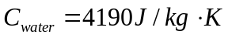and the latent heat for water changing phase to ice 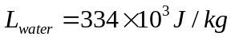.

8. [10 Marks] A 5.00-kg block is suspended from an ideal spring of negligible mass. When the block is pulled down 0.100 m below its equilibrium position and released, it vibrates with a period of 4.20 s. (a) What is its speed as it passes through the equilibrium position? (b) What is its acceleration when it is 0.05 m above the equilibrium position? (c) When it is moving upward, how much time is required for it to move from a point 0.050 m below its equilibrium position to a point 0.050 m above it?
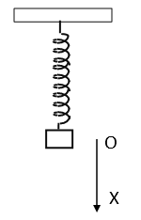

9. [10 Marks] A transverse wave on a string has wave speed 8.00 m/s, amplitude 0.070 m, and wavelength 0.320 m. The wave travels in the negative x direction. At t=0 the end of the string (x=0) has its maximum upward displacement. (a) Find the frequency and period of the wave. (b) Write a wave function describing the wave. (c) Find the transverse displacement of a particle at x=0.360 m at time t=0.150 s.

10. [8 Marks] A uniform film of TiO₂ with thickness of 1036 nm and index of refraction 2.62 is spread uniformly over the surface of a glass plate of refractive index 1.52. Light of wavelength 520.0 nm falls at normal incidence onto the film from air. It is found that this TiO₂ film does not cancel the reflected light properly. You want to increase the thickness of this film so that the reflected light cancels. What is the minimum thickness of TiO₂ that you must add so the reflected light cancels as desired?

11. [8 Marks] Jupiter is 5.93×10⁸ km away from the earth orbit. You are asked to design a space telescope to resolve features on Jupiter that are 250 km apart. What minimum diameter of the telescope is required? Assume a wavelength of 500 nm.

